**OverTheWire Bandit - Level 10 to Level 11 Writeup**

**Introduction**: This writeup documents my experience solving Levels 10 to 11 of the OverTheWire Bandit challenge, a CTF-style game focused on learning about security concepts.

**Author**: Misha Jain

**Date**: October 19, 2023

**Tools Used:**

Terminal (SSH client)

**Challenge Description:**

Level 10 to Level 11 of Bandit involves connecting to a remote server via SSH and finding a password stored in the file "data.txt," which contains base64 encoded data.

**Enumeration:**

For Level 10, we need to connect to the server using the credentials we obtained in Level 9. Our goal is to find a password stored in the "data.txt" file that is encoded in base64.

**Exploitation - Level 10:**

To connect to the server for Level 10 using SSH, we use the provided credentials:

ssh bandit10@bandit.labs.overthewire.org -p 2220

Use the password obtained from Level 9, which is G7w8LIi6J3kTb8A7j9LgrywtEUlyyp6s to gain access.

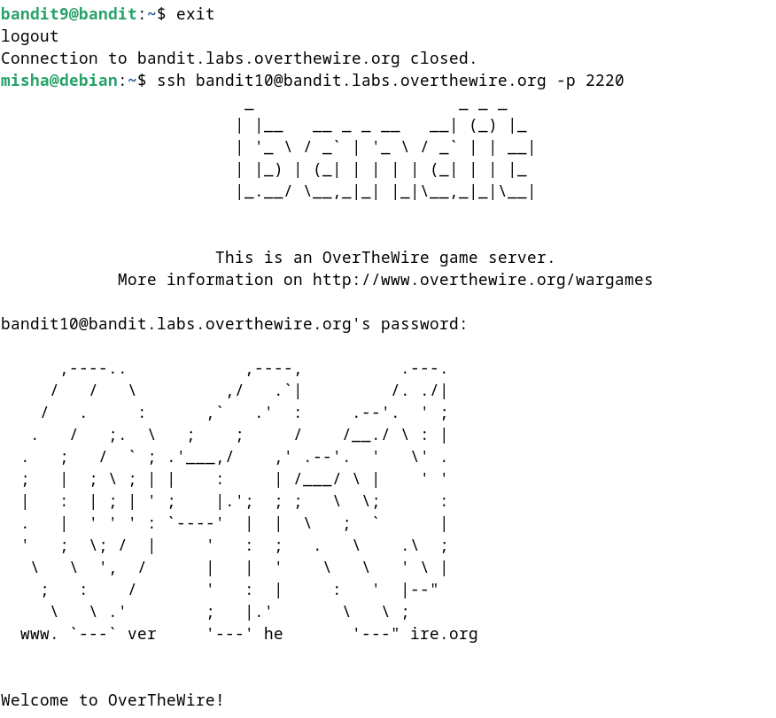

**Password Retrieval - Level 10:**

The password for Level 11 is stored in the file "data.txt," which contains base64 encoded data. To check the contents of the data.txt file, we can use the cat command.

cat data.txt

To decode and extract the password, we can use the base64 command to decode the contents of the file.

base64 -d data.txt

This is the base64 encoding and decoding command. The -d option tells the base64 command to decode the data.

These commands will display the Level 11 password.

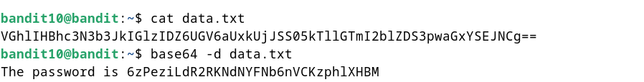

**Password – Level 11:**

The password for Level 11 is: 6zPeziLdR2RKNdNYFNb6nVCKzphlXHBM

**Exploitation – Level 11:**

Now that we have the Level 11 password, we can connect to the server for Level 11 using SSH:

ssh bandit11@bandit.labs.overthewire.org -p 2220

Use the Level 11 password to gain access.

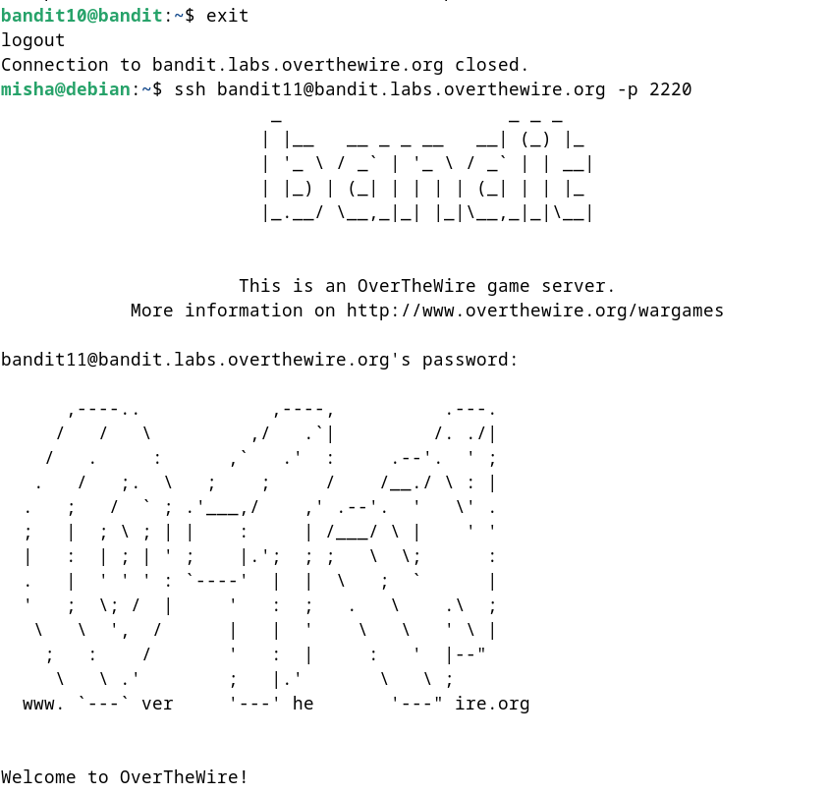

**Lessons Learned:** Level 10 introduced us to using the base64 command to decode base64 encoded data and extract information. This level reinforced the use of text processing commands and data manipulation.

**Conclusion:**

Levels 10 to 11 of the OverTheWire Bandit challenge continue to build on shell command knowledge while introducing new challenges involving data encoding and decoding. These levels are suitable for beginners to learn more about handling encoded data and file manipulation.